Benchmark - Final Project Management Plan and Project Retrospective

Ektaben Ravalji

Grand Canyon University: MGT-665

March 04, 2020

**Project Information**

**Case Topic:**“**The Martial Arts Academy – School Management System**”

**Project Name:** School Management System

**Project Team Name:** Management System Consulting LLC. 

The Martial Arts Academy needs a functional business management tool. The School Management System will be a viable solution that can assist in the planning, organizing, and disseminating information for the organization.

**Team Members**

|  |  |  |
| --- | --- | --- |
| **Name** | **Email Address** | **Phone Number** |
| Ektaben Ravalji | annu2012310@gmail.com | (832) 791-9801 |
| Erik Traulsen | erik.traulsen@gmail.com | (206) 427-0695 |
| Thomas Moore II | tmooreii@yahoo.com | (281) 690-1110 |
| Alyssa Woodworth | alyssa.woodworthgcu@gmail.com | (360) 551-3409 |
| Gerald Walton II | geraldwaltonii@gmail.com | (82) 10-2131-8734 |
| Peter Martinez | peter.martinez@gmail.com | (489) 440-6018 |

**Project Description**

Martial Art Academy (MAA) is a small martial art training school which was owned by Grandmaster Taylor. But he decided to sell the business and now the business is handled by Geoff and Julie who are black belt holders. The number one priority of Geoff and Julie is to finding ways to stay in business, hold their current students base and simultaneously fascinating new students to the academy. To accomplish this goal, they both have decided that employing a new information system should assist them to better manage the routine tasks needed more effectively and efficiently as the current system is done through file cards that list out when a student is scheduled.

**Measurable Organizational Value (MOV)**

The overall goal of proposed system is to provide a secure information management system for the Martial Arts Academy (MAA). This system would help the owners manage the daily operations more efficiently and effectively so that they can devote more time teaching learners the lessons and traditions first taught by Grandmaster Taylor. The owners are concerned with making sure that the system not only converts the process from a paper-based system to a digital one but that it also adds value by providing a way to track user participation and more useful analytics.

As a measure of its success, the owners have requested to have a monthly newsletter developed and sent out based on user data captured and outputted with a set of canned reports that will be created during the development process. For measuring the project success, some desired goal must be accomplishing. Such as, project should complete within decided budget, within the deadline, development and installation of a system successfully, and client must able to access customer data for reporting, analysis and marketing, etc.

**Scope Management Plan**

The main reason behind building this project is to develop highly secure software and database system to allow the comfort to data storage, collection and data management. Employment of this system brings easier management system on collected data, customer interaction and satisfaction. Daily activities, like managing the new and existing data is very time consuming. But, introduced project will save this time. For successfully implementing this project, the organization need very effective scope management plan. This plan defines the project charter and WBS. Project Scope is the stages of project planning in which, we as a developer, identifies the budget, project’s goals, deliverables, schedule, required resources to execute tasks and outcomes.

* **Requirements:** The owners are concerned with making sure that the system not only converts the process from a paper-based system to a digital one but that it also adds value by providing a way to track user participation and more useful analytics. As a measure of its success, the owners have requested to have a monthly newsletter developed and sent out based on user data captured and outputted with a set of canned reports that will be created during the development process.
* **Scope Statement:** The Martial Arts Academy is a smaller martial arts studio that has recently been taken over by two black-belt instructors when the original owner decided to retire. With them taking over the business, their number one priority is finding ways to stay in business and retain their current base of students while concurrently attracting new students. To accomplish this goal, they have decided that implementing a new information system should enable them to better manage the daily operations needed more effectively and efficiently as the current system is done through file cards that list out when a student is scheduled to come in and when there test for promotion will be.

**Roles & Responsibilities:**

|  |  |  |
| --- | --- | --- |
| **Team Member** | **Role** | **Name** |
| **Executive Sponsor** | The Executive Sponsor is normally a senior member of the company who for the ultimate business success of the project. When decisions and problems get escalated it is often them that has provides the final decision and direction. | Peter Martinez |
| **Project Manager** | The project manager is responsible setting the schedule and ensuring that the project is being completed on time. It is there responsibility to assist in removing any roadblocks that could potentially add risk to the project. | Alyssa Woodworth |
| **Business Lead** | The Business Lead is responsible for the execution of the project and is the owner of the product being created or changed. They are also the owners of the business requirements and decisions as they relate to the project. | Ektaben Ravalji |
| **Development Lead** | The development lead oversees helping to design the solution and assigning work to the different developers on the project. | Erik Traulsen |
| **Test Lead** | Test leads will help with designing the test cases and provides a QA signoff once the test cases have been completed. | Gerald Walton |
| **Core Team Members** | The core team members are the people responsible for creating and testing the product, they will be the ones who ultimately complete the user stories and test cases. | Thomas Moore II |

**WBS/ WBS Dictionary:** Below figure shows the work Breakdown Structure of the project completion.

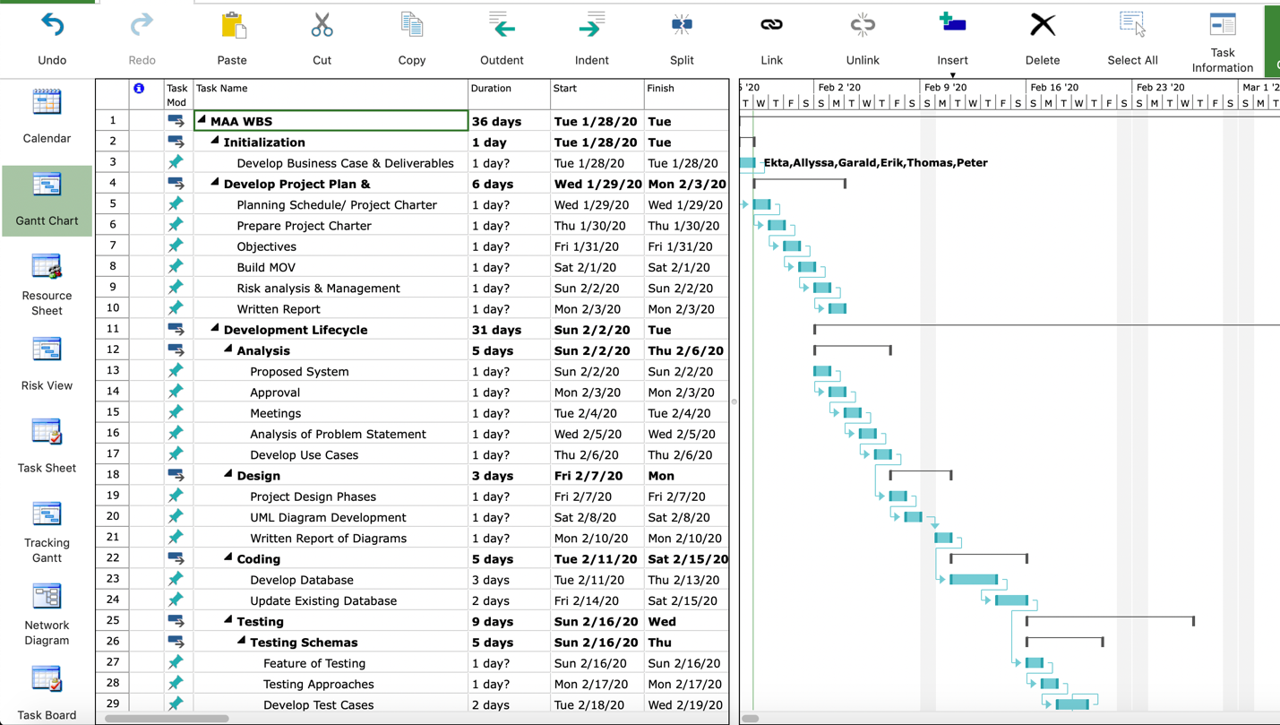

WBS Continue…

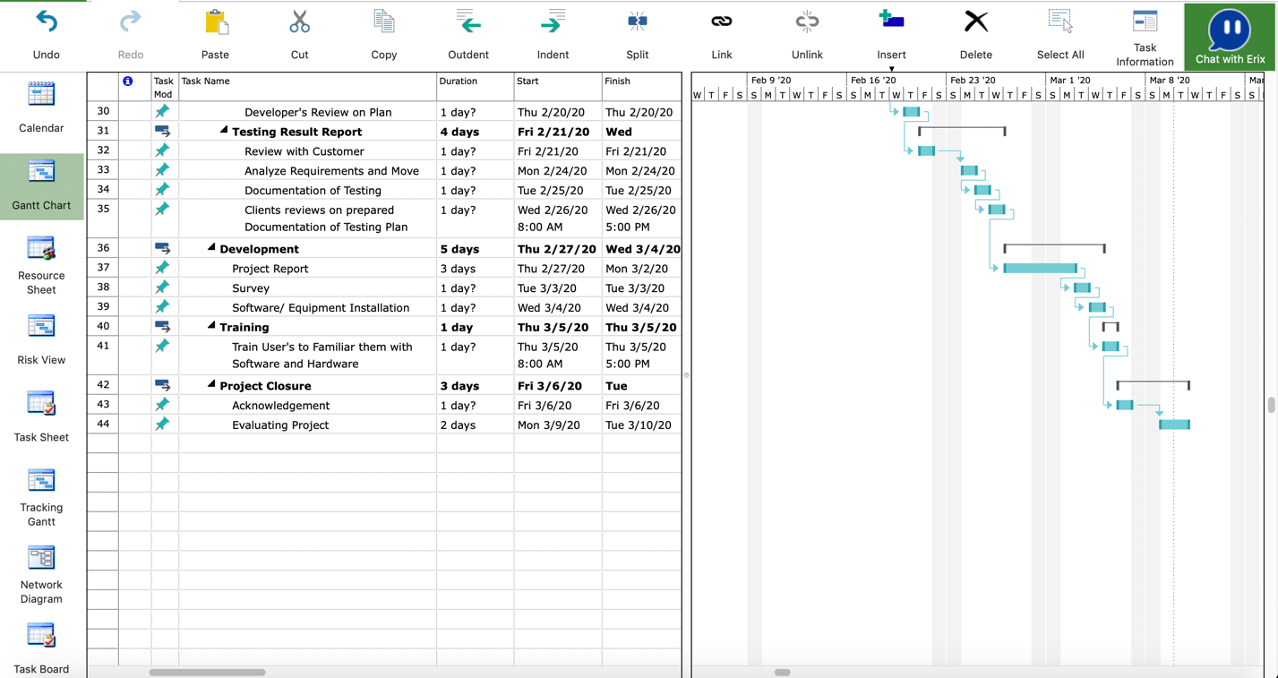

The Martial Arts Academy would benefit the most from generating an in-house information management system as they consider transitioning from physical documents to an online system. Due to the expected growth of the organization, managing their own system would be both cost beneficial and benefit the overall security for the organization. As shown above in WBS, passing from all schedule of planning, we can see that the project has taken too long over the completion date. Moreover, also some activities have taken more than 4 to 5 days. And, the cost of project is under estimated budget, thus, the project is built in good cost. But time taken by project is so long. the reason behind this should be poor management skill of management.

**Project Schedule**

The most common form of schedule is a Gantt chart. Gantt chart creates the milestone schedule and detailed project schedule. we can use different tools to make project schedule. Here, for Martial Art Academy- School management system I’m using Microsoft Project management tool for represent the Gantt chart or schedule of project.

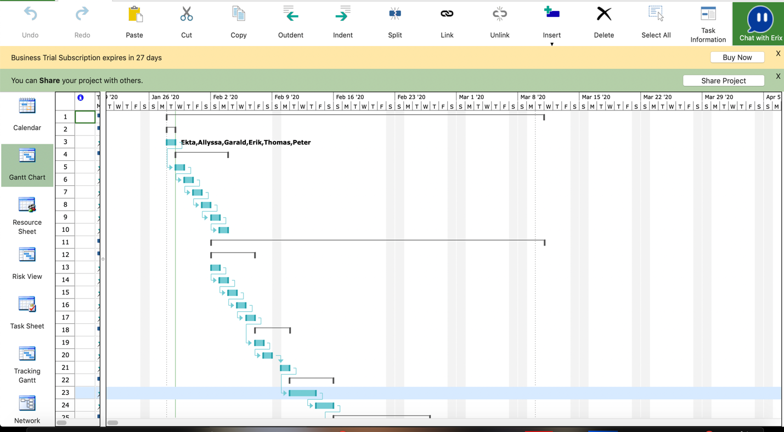

* Continue.

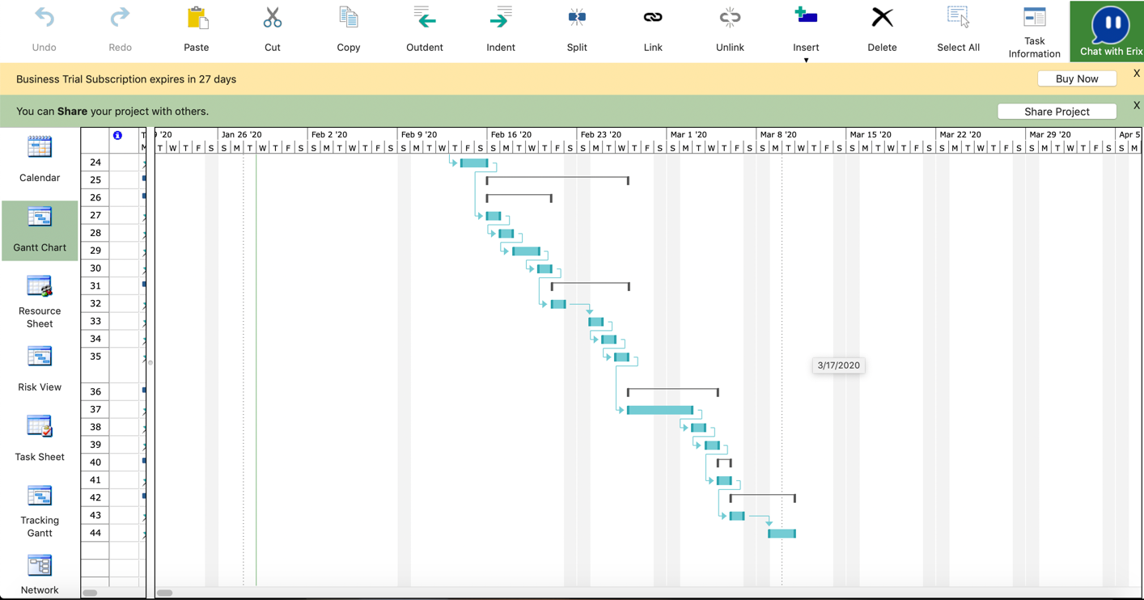

**Budget Management Plan**

The good budget management plan reflects probabilities of the project success. Budget plan also helps to keep a track on activities and how much financial balance you need to completion of your project. At the end of the day, knowing how much money we have and how much we need to spend more to accomplish the goals and deliverables of the project. The final calculation of subtracting cost and expenses form sales shows the profit earned. By knowing profit, we can forecast the project success.

Here, in Martial Art School project, the project built under budget, but the main problem is time management. Some of task or activity took long time to complete. Here, in below figure you can see the balance sheet and budget of last three years (All costs and expenses are taken approximately).

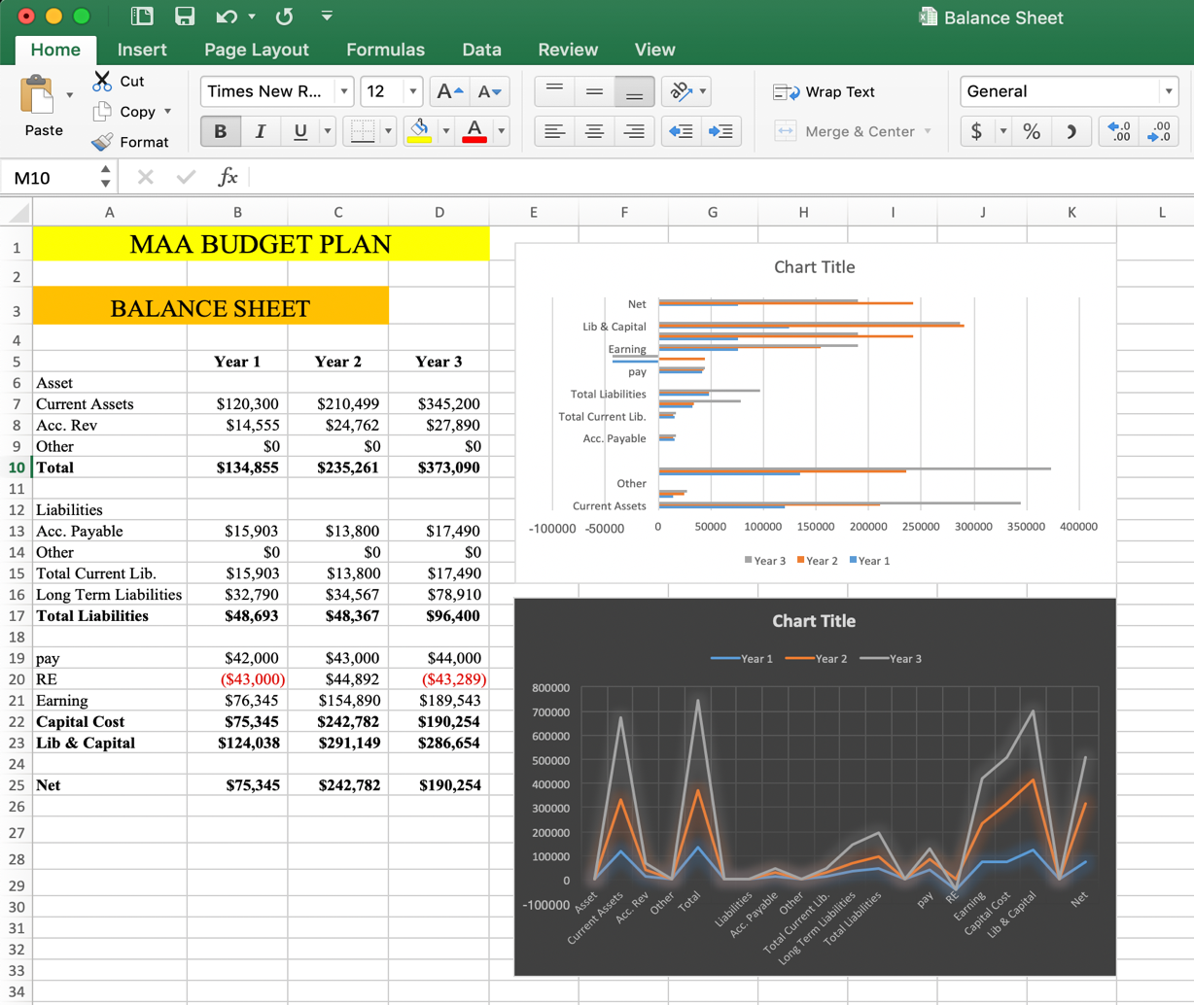

Continue.

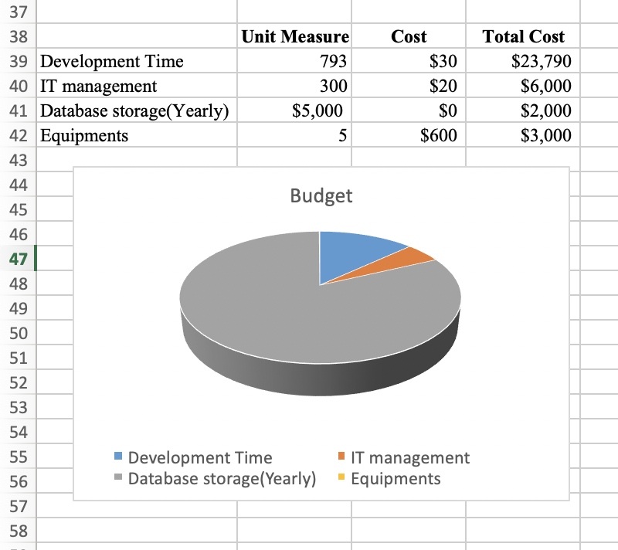

**Risk Management Plan**

1. With respect to Project Methodology and Project cycle Phases, the initialize is very first phase. During this phase, we need to concentrate on the requirements of project. Accordingly, we need to divide our team with specific role and responsibilities of each member. The major risk in this stage is of overestimation of feasibility. During the period of analyzing, expenses on the resources which are not possible to install in the project can drive the entire project at failure. This type of risk is considering as an Internal Risk.

**The responsible member for this risk:** Business Leader

**Strategies to manage this risk:** This type of riskcan be forecasted, and manageable because this risk is face within team members and business leaders. As a leader, you just need to concentrate on the needs of particular project. If you wish to use the resources which is not possible or which are over budget, then it’s necessary to eliminate that resources from your project.

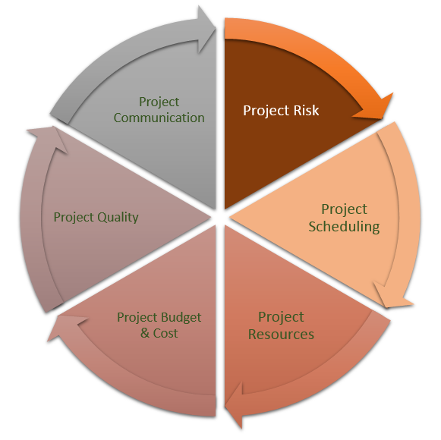

**Fig 1: Project Risk Management Plan**

1. The second level of project phase is Planning and Development phase. During this phase we face the risk of the improperly separating the tasks to the member who cannot perform best in that activity. In short, the risk of role and responsibility. Additionally, we also face the time complexity risk in this phase. This risk also considers as internal risk. Uncertainty of work distribution cause a major failure of project.

**The responsible member for this risk:** Project Manager

**Strategies to manage this risk:** To overcome this risk, as a project manager you should analyze the strong and weak side of your team member. Once you identify the skills and knowledge, handover the task to each team member in which they can do their best. Additionally, during development phase of any project we cannot forecast the success of failure of project. Even we cannot assume how much time will take by each task. So, as a project manager, you should keep a buffer time at the end of each task. For example: Suppose you get any error, bug or any other issue after completion of particular task, if you have buffer time in your schedule, you’ll have enough time to fix that problem.

1. The third phase or level is execution or control phase. Under this phase, we face the risk of scope creep. During the execution phase we installed innovative functionalities in current project. As a result of that, we run the risk of scope creep. We had start development with few resources and now we had assed few new resources, and functions to existing project. It directly affects our base budget. Ultimately, our project is going over budget. Moreover, the new functionality took too long to be installed. So, the project also runs behind the targeted deadline.

**The responsible member for this risk:** Development and Testing Team Leaders

**Strategies to manage this risk:** Introducing new functionalities to existing project drive entire project towards failure. In this circumstances, development team should prepare the list of requirements and the specifications related to each requirements. Also the team should develop the chart of estimate time, will be taken by each development phase. If you do so, your project will develop in budget and under deadline. Proper control after each iteration is necessary over here otherwise you will develop (run) the product, which is not expected by the business owner or client.

1. Closure is the next phase of project cycle. if your project doesn’t match the requirements it will affect the project scope, schedule and the original budget of the project. During this phase there could be a risk of develop final product or system would not match the basic requirements of the Measurable Organizational Value. The owner of this risk would be the lead developer, project lead and client stakeholder as the deployment and close will only be effective if it is heavily participated in by the client and the project team. This risk is considered as known- unknown risk.

**The responsible member for this risk:** Development Leader and Business Leader

**Strategies to manage this risk:** As a project developer, you should make sure that your project’s final product should meet all the original and basic requirements according to the MOV of your project. Moreover, delivery product’s scope, schedule and budget plan should properly have utilized for the development.

1. Last and final phase of project cycle is Evaluate. This risk is known-unknown risk as bugs are typically not identified until the testing phase of the project life cycle. During this phase the successful evaluation of final product is necessary. If you are not valuing your product properly, the project will run errors and bugs which will impact the use of the project.

**The responsible member for this risk:** Project Leader and Sponsors

**Strategies to manage this risk**: To overcome this risk, project leader should test the final product before handover the project to the client. If in case the project leader have already launched the project, he/she should take a feedback from end user. And if end users will face bugs, project leader should correct the project again. This process is very complex, so as a project manager and sponsor you should test the project before launching it.

**Quality Management Plan**

**Principles and Philosophy:** Quality Management Plan controls the level of characteristic of project described by client and also describes the metrics of how the project will meet the level of quality in the terms of its deliverables and processes. The key components of QMP are as below:

* Quality Objectives:
* Key Deliverables:
* Quality Control and Assurance:
* Quality Roles and Responsibilities:
* Quality Tools:
* Reporting Plan of Quality Control:

Quality control monitors project deliverables to verify that the deliverables are of acceptable quality and are complete and correct. The framework Given below provides the basic idea for quality management plan which is based on project deliverables.

|  |  |  |  |  |
| --- | --- | --- | --- | --- |
| **Quality Management Plan** | | | | |
| Principles | Quality Standards, Processes and Metrics | Quality Assurance | Quality Control | Learn, Improve & Mature |

**Quality management Statement:**

Project team is working with two criteria simultaneously, system design process and control process to measure the quality of project. The existing project of MAA uses the principles of the methodology during whole the development phase.

**Quality Metrics:**

According to some research of author (J. Spacey,2017), “quality metrics are a main element of an effective quality management plan. In other word quality metrics are the amounts used in ensuring customers receive suitable products or deliverables.” Some quality based metrics are given as below according to their category.

|  |  |  |
| --- | --- | --- |
|  | **Metrics 1** | **Metrics 2** |
| **Process Category** | **Turnaround Time:** It is total amount of time taken to fulfill the requirements of particular task. | **Take Time:** It is the total time between staring one activity to starting the next activity. |
| **Product Category** | **Customer Retention:** It is also known as Churn Rate. Churn is a measurement of the percentage of accounts that cancel or choose not to renew their subscriptions. Churn is the measure of how many customers stop using a product. | **Lifetime Value:** LTV is an estimate of how much revenue an account will bring in over its lifetime. LTV, when used alongside an efficiency metric when gauging the cost efficiency of a given acquisition strategy. |
| **Project Category** | **Cost Variance:** Cost Variance dealings planned expanse alongside money actually spent. By using this metrics in MAA project our team keep eyes on percentage of budget used. Cost Variance tells us immediately if our budget is working. | **Gross Margin:** This metrics is very useful for our project. By using this metrics, we have keep track on how our project is doing and how much money our project is going to make. |

**Set of Verification Activities:**

Verification Activity is the process of evaluating periods which is monitor development phase to determine whether they meet the project requirements for that particular stage or not. This activity takes place before the validation activity. The Verification Activates include evaluation of project requirements, plans, documentations, and, specifications. This activity is also known as **Quality Assurance**. Quality Assurance (QA) is actually used to ensure developers and corporate managers, see how and at what level of quality the actual software process flows to meet the requirements of development phase (J. Spacey, 2017).

**Set of Validation Activities:**

Validation Activity is the process of evaluating product through development phase to determine whether product meet the project actual requirements or not. This activity takes place after the verification activity. The Validation Activates include evaluation of product. It means validation is the testing of final product. This activity is also known as **Quality Control**. At the end of this activity we get our projects final and quality product. Three types of testing techniques are take part in this activity i.e. **Unit Testing, Acceptance Testing** and **Integration Testing.**

**Change Management Plan**

* **Change Sponsor:** As we are implementing the new management system for Martial Art Academy (MAA), the main sponsors of the organization are Julie and Geoff. They are the two Black- belt instructors of MAA. Also the sponsors are obligated to accompanying the change in project, if any. If they are not supporting the change, project can be failed (Marchewka, 2015). As a result, sponsor’s authority could be loss.
* **Change Target:** Change target must be a people who will affected by the change. Here in Martial Art Academy (MAA) project the change target must be:
* Martial Art Academy’s Instructors
* Students
* Parents or Guardians
* **Agents:** According to Author (Marchewka, 2015), “An agent may be an individual or group responsible for making the change happen in order to achieve the project’s goal and objectives.” Therefore, the change agents here are:
* Development Team (Ekta, Alyssa, Erik, Gerald, Peter, Thomas)
* Project Manager

**Change Assessment**

1. **Willingness:** Grandmaster Taylor has decided to sell his business to Julie and Geoff who are the Black- belt instructor of MAA. And they both decided to develop new management system for MAA. Old system was paper based and it is very difficult to keep eyes on all records. That’s the reason, Julie and Geoff wants to change the existing management system. but some percent they both are worried about the new system. How will be it works? Is it under budget or not? Will everyone comfortable with the innovation or not etc. But, at the end they both are on same side to change the management system.
2. **Readiness:** After the clarification of requirements, scope, budget and the schedule, Geoff and Julie shows their readiness to start the work on new development system. Julie and Geoff wants to change the existing management system. But some percent they both are worried about the new system. How will be it works? Is it under budget or not? Will everyone comfortable with the innovation or not etc. But, at the end they both are on same side to change the management system. Moreover, as an author (Marchewka. J, 2015) said, Trace- a black- belt instructor was not sure on changing the system because he feels the system will be difficult to understand, but he also gives a green signal to change system.
3. **Ability to Change:** The development team has good and innovative technology to develop the new and very effective management system for MAA (Martial Art Academy).Moreover, all the members of team are able to handle their role and responsibility towards their project.

**Change Strategies**

**Rational-Empirical:** The Empirical-Rational strategy is very challenging to install when the motivations available are uncertain. Some people are rational creatures and they will follow their egoism, once it is revealed to them. Effective change is built on the interaction and collaboration of information and the extending of motivations. Based on J. Marchewka (2015) idea, “a change agent must be persuasive in convincing, explaining, and demonstrating how a particular change will benefit a particular person or group identified as a target of the change.”

1. **Normative- Reduction:** According to Fred Nickols (2016), “The Normative-Reductive strategy focuses squarely on culture, what people believe about their world, their work and themselves and the ways in which people behave so as to be consistent with these beliefs.” The culture of any organization is as much in the control of the casual organization as it is the formal organization. The key principles (Marchewka. J, 2015) of this approach are:

* Preference and prejudgment toward guarding one’s closely held beliefs and values moderates one’s ability to think rationally.
* Effective change requires changing for both person’s value and team’s culture as well.
* Ability for change is directly linked to a member’s contribution in a team.

1. **Power- Coercive:** In this case the external authority mandates the organizational change, and they feel that this change is good for everyone. But, when the employees or users refuse this proposal, the external authorities imposing sanctions to use that new system.In short, this is the one type of influencing the people to do what the external authority wants. Author Marchewka (2015) says, “The power-coercive approach to change management attempts to gain compliance from the change targets through the exercise of power, authority, rewards, or threat of punishment for nonconformance.” In such cases, the targets of change recognize the legitimate power or expertise of the change agent.
2. **Environmental- Adaptive:** The Environmental Adaptive strategy uses the adaptive nature of the individuals. Generally, people do not like loss and instead of trying to change the people you can build another organization and shift people there so that they work in the new environment according to the fresh policies. The Environmental-Adaptive strategy is suitable for places where major, transformative change is called for.

**Process Tracking**

At this phase, Change Managers face significant challenges when it comes to tracking the status of changes and change requests throughout their lifecycle. There are some processes to keep track on change management process as shown below:

* Put the Best Member in the Best Place
* Identify Conflicts
* Conduct Meetings
* Be Ready for Correction in Every Phase

There are some different criteria’s we should track when we are managing a change process. Such as, description of change request, the agents who requested for change, priority of element, etc. By following this steps we can easily track the full change management process.

**Tools for tracking change management process are:**

* WhatFix
* BMC Remedy Change Management 9

### ChangeGear Change Manager

* StarTeam
* Rocket Aldon
* Give eChangeManager

**Project Implementation and Closure Plan**

**A conversion strategy**

1. **Parallel Method:** For this project, we will choose Parallel Method conversation strategy for adopting new system. This is the process, existing system and the new system are working simultaneously (Parallel) in organization. By using this strategy for our project of Marital Art Academy (MAA), it’s very easy for us to find smallest errors and bugs of the project.Moreover, if in case we will not able to implement the new system than, there is no risk of losing anything. Adopting this conversation strategy for our project, allow us to fix the errors in new implemented system before we ending the old system.

**A Closure Checklist**

|  |  |  |  |
| --- | --- | --- | --- |
| **Project Closure Checklist** | | | |
| **#** | **Activities or Tasks** | **Completion Status (Y/ N)** | **Remarks** |
| 1 | Team Selection |  |  |
| 2 | Receive Acceptance Latter from Sponsor |  |  |
| 3 | Developed Meetings/ Communications/ Presentations Plans |  |  |
| 4 | Implementation Strategies Development |  |  |
| 5 | Completion of Project Deliverables and Measurable Organizational Value **(**MOV) |  |  |
| 6 | Cost Calculation For Final Product |  |  |
| 7 | Completion of Pending Activities |  |  |
| 8 | Implementation Strategies for Testing |  |  |
| 9 | Identified Errors and Bugs |  |  |
| 10 | Solved Issues |  |  |
| 11 | Resource Assigned for Unresolved Issues |  |  |
| 12 | Development of Closure plan |  |  |
| 13 | Written Closure Plan |  |  |
| 14 | Final Written Project Report |  |  |
| 15 | Lesson Learned Meetings |  |  |
| 16 | Project Sign-off Received |  |  |
| 17 | Documentation Of Project Sign-off |  |  |
| 18 | Payment Received from Client |  |  |
| 19 | Team Members Payment |  |  |
| 20 | Final Closing of Project |  |  |
| 21 | Success Celebration |  |  |

On the other hand, we would not choose **Phased Method** because, it takes a lot of time to install the whole new system to the entire organization. In short, this strategy is time consuming. And we would not choose **Direct Cutover** as well because, it is very risky because it is not always that implementation of new system is successful every time. Additionally, error detection in this strategy is very hard. Because of this, some errors or bugs can terminate the whole system and also can cause some difficulties in the backup process as well.

**A Project Evaluation**

According to Peter Landau (2018), “The project evaluation process uses systemic analysis to gather data and reveal the effectiveness and efficiency of your management.” It includes the feedback on each employee or team member’s individual performance, project audit, and the comparison of current result of project with original Measurable Organization Value (MOV). Also, it includes the impact of product that links to the deliverables as mentioned in main document of the recent project. The final product of MAA project will resolve the problem of storing day-to-day activities of employees. It will be easy to enroll new student in the academy and for instructor to concentrate more on student’s training. Moreover, the developed system is alike the older system, so it will be pretty easy to use and understand the implemented system, just little change is, form paper based to system based. Evaluation also allow us to take part in audit the project from other organization.

**Project Retrospective**

At the beginning level of these project we had decided to change the older paper based system of Martial Art Academy (MAA) to online software (Equipment) based system. The Martial Arts Academy would benefit the most from generating an in-house information management system as they consider transitioning from physical documents to an online system. Due to the expected growth of the organization, managing their own system would be both cost beneficial and benefit the overall security for the organization. The organization would benefit from making changes to an in-house information system instead of having to switch systems when it no longer fits the needs of the organization. Half way of the project we realized that, we need more resources to implement the innovative system and we also had a good budget for these project. But, the implementation time was too long. We run out of schedule to accomplish the project goals on time. As soon as we realized that issue, we thought to extend our deadline for this project. That decision of extending deadline was beneficial for our project and we completed our project after.

The innovative system is easy to use for employees as well as for instructors as well. Moreover, the instructors of Martial Art Academy (MAA), can concentrate on giving well training to their students without any concern of management system. Older system was run on the paper based approach but, this new developed system is fully equipment and online base. Hence, the stress level of employee (for management), instructors (on training), students and parents is reduced.

**References**

Marchewka, J. (2015). Chapter 1: What is project management. *Information Technology Project Management*. Retrieved from: <https://viewer.gcu.edu/b22Pmj>

Standard Operating Procedures & Risk Management Policy. (2013). Retrieved from: <http://www.martialarts.com.au/mtcmedia/2017-03-29-General-Martial-Arts-Risk-Management-Policy-MAA.pdf>

J. Spacey. (2017). 7 Types of Quality Metrics. Retrieved from: <https://simplicable.com/new/quality-metrics>

B. Lempert. (n. a). 5 Critical Metrics for Project Management. Retrieved From: <https://www.clicktime.com/blog/5-critical-metrics-for-project-management/>

F. Nickols (2016). Four Strategies for Managing Change. Retrieved from: <https://nickols.us/four_strategies.pdf>

(n. a.). (2020). How to Lead a Change Management Process? Retrieved from: <https://www.projectmanager.com/software/use-cases/change-management>

P. Landau. (2018). How to Improve Your Project Evaluation Process? *ProjectManager.* Retrieved from: <https://www.projectmanager.com/blog/improving-project-evaluation-process>

M. Hussain. (2016). Conversion Strategies. *Principles of System Development*. Retrieved from: <http://creativehive.org.uk/mishaalhussain/2016/03/15/conversion-strategies/>

R. Levine. (n. a). 5 Reasons Why Evaluation Matters to Your Project. Retrieved from: <https://www.nichq.org/insight/5-reasons-why-evaluation-matters-your-project>